*Florida International University*

*School of Computing and Information Sciences*

Software Engineering Focus

Feature Document

User Story ID #336

**Name:** Improve user login

**Team Member(s): Juan Hernandez**

**Project: Virtual Roll Call 4.0**

**Product Owner(s)**: Jason Cohen

**Mentor(s)**: Juan Caraballo

**Instructor**: Masoud Sadjadi

**User Story Name:**

* Description: **As a** User **I would like** to see the login screen after i log out and i try to access any feature of the system **so that** no other user can access the system under my user access even though it shows null

Acceptance Criteria

* Users log off but if they access any section of the system by copy and pasting the URL in the browser

**Use Case**

* Name: Login
* Actor: Juan Hernandez
* Preconditions:
  + Juan login into the system
  + Juan copy the URL after accessing any section of the application
* Description: Juan logoff the system and close the browser. Juan open the browser again and paste the URL copied in the address bar and press enter. The system grants access without prompting login screen and shows “null” as user. Juan can access any part of the system under the previous logged in user’s role.

**Use Case Diagram N/A (Defect)**

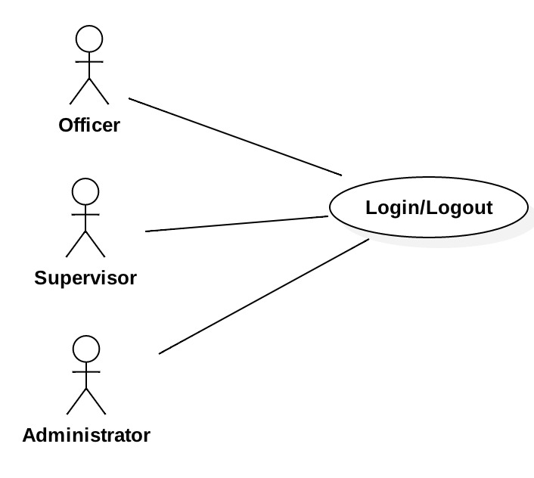

**Sequence Diagram**

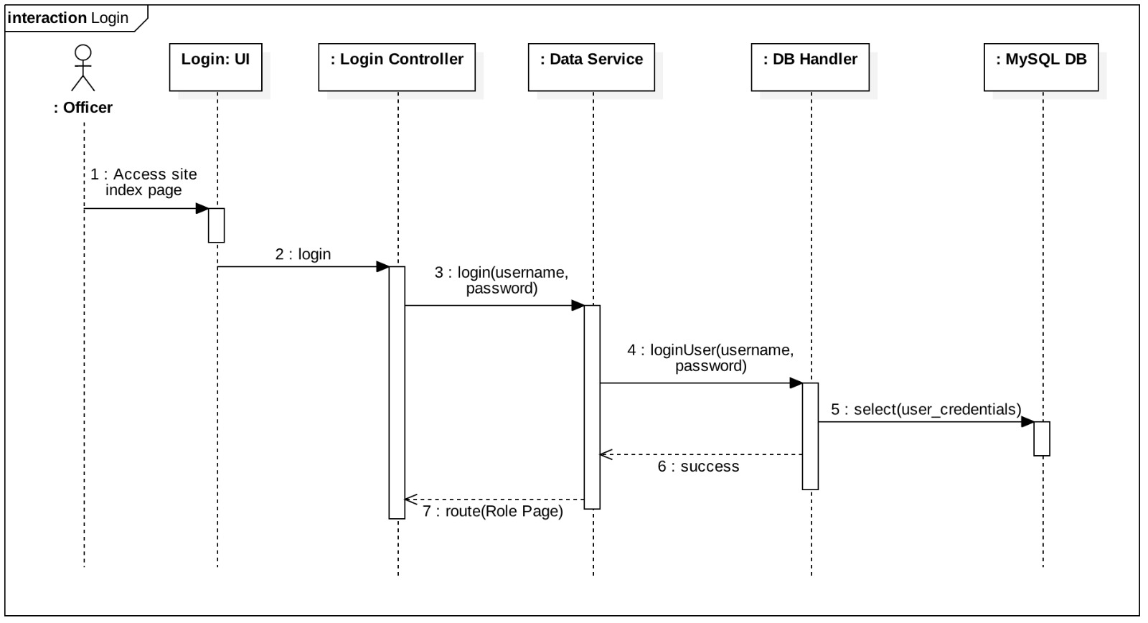

**Class Diagram**

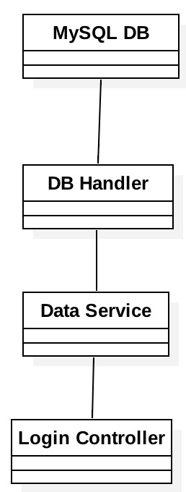

**Unit Test**

* Test case ID: 1
* Description/Summary of Test: The user will logoff after copy the URL. Then the user will close and open the browser again. The user will paste the URL and the system will show the login screen.
* Pre-condition:
  + User is logged in.
  + User has copied the URL
* Expected Results: User logoff after copy the URL and close the browser. User open the browser and paste the URL. The system will show the login screen
* Actual Result: User logoff after copy the URL and close the browser. User open the browser and paste the URL. The system will show the login screen
* Status (Fail/Pass): Pass

**Integration Test**: N/A

**Visual User Guide:**

